An Important Visitor
John Heath, inventor of the swinging arm disk head technology, visited the museum in December and donated a Kestrel and a cutaway Redwing. He also donated his first two prototype swinging arms and some slides. Swinging arm technology was not generally adopted in IBM; other laboratories clung on to the old push-pull. However it became the most licensed IBM electro-mechanical patent of all time, and John estimates that to date several billion hard disks have been produced using his invention.

Where It All Started
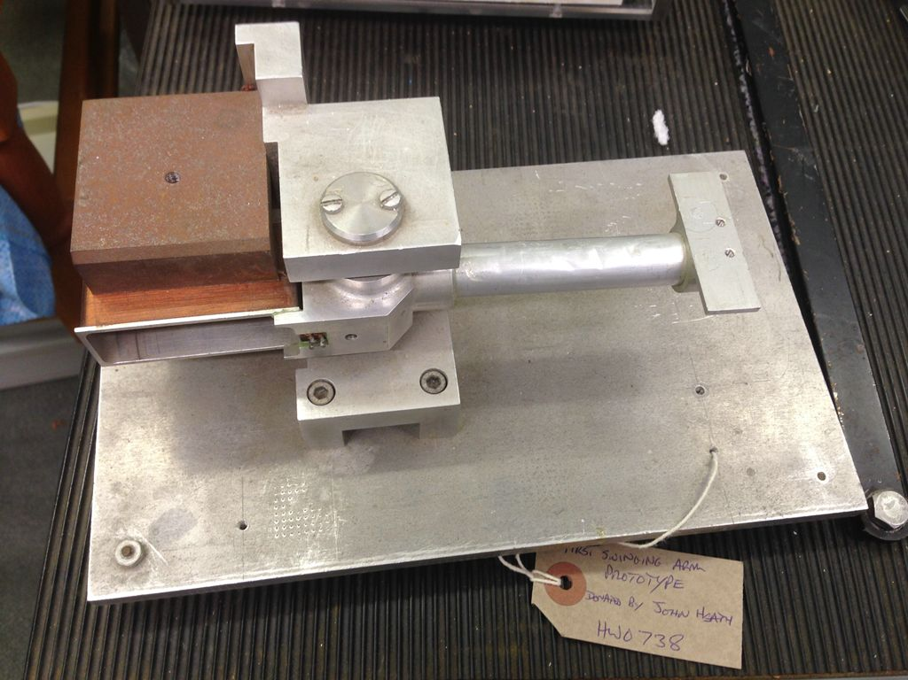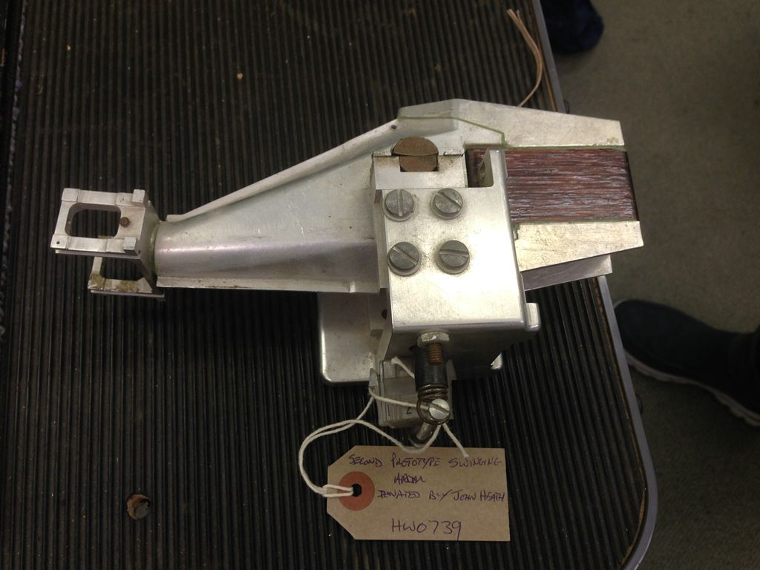
First prototype Swinging Arm Second Prototype Swinging Arm

John also helped the museum to identify an artefact that has puzzled us for a while. A small plastic box full of small magnetic strips, labelled ‘Zenith’ and ‘First Hursley Storage Project.’ There was also a matching cartridge containing more strips. It turns out that John was hired specifically to work on this project!

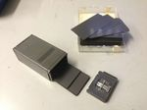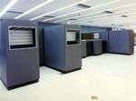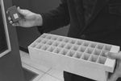
Our Zenith chips and cell IBM1360 Tray for loading cells

In the mid-1950s the CIA asked IBM to produce a system for the mass storage of printed documents. Codenamed Walnut the IBM1350 was developed using small pieces of Kavlar photographic film, called chips, stored in small boxes called cells fitted to boxes in a carousel. Due to some unpleasant characteristics of Kavlar, IBM redeveloped the system codename Cypress, the IBM1360, in the hope of commercialising it using standard photo film technology. A full description of these two systems is in Wikipedia at https://en.wikipedia.org/wiki/IBM_1360.

Meanwhile IBM decided to seek a cheaper magnetic storage solution to produce higher densities and faster operation using the same format. This was Zenith, the low cost version. Development never came to fruition, as other forms of magnetic media were becoming available.

Current Activities & Acquisitions
We have purchased an IBM-badged desktop printing calculator from eBay. This is almost certainly a rebadged OEM calculator.

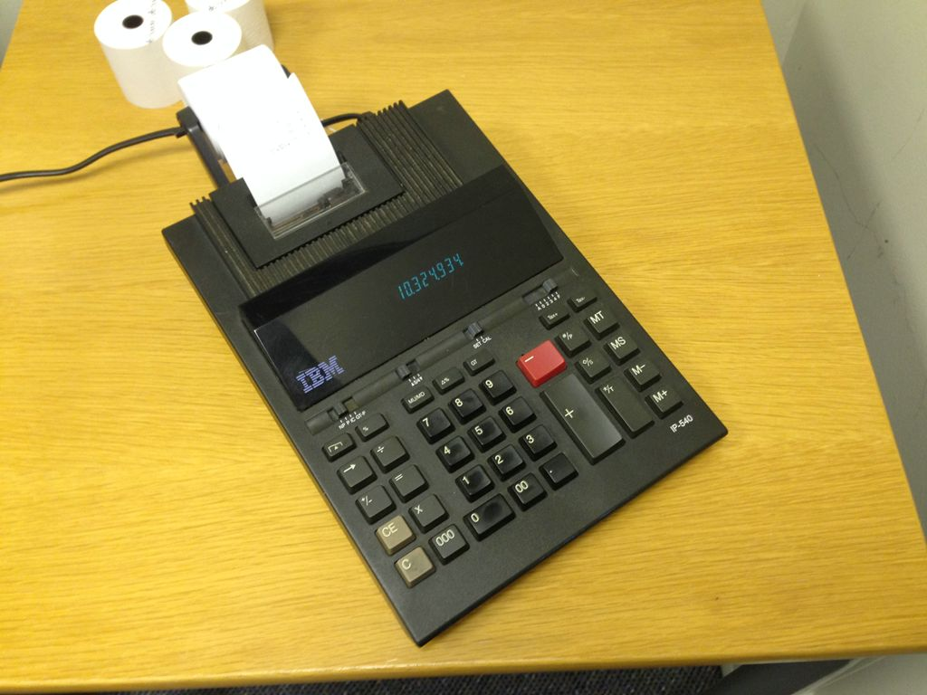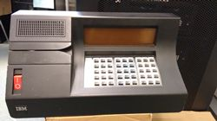
Printing Calculator IBM 3604 Banking Terminal

Further donations include 2 x 3604 banking terminals, more PS/2s and some miscellaneous keyboards including Arabic / Farsi. We also managed to rescue more SSA adapters and disks, some new 8" floppies and miscellaneous documentation from the Storage Development group.

New Display Items
We have added Zenith to the magnetic device display cabinet.

Other
To improve visibility of our loans, we have now updated the web site to display a summary of each person / location, behind which is a list of artefacts on loan.

